**Lab 00 – MyFirstProgram**

Open BlueJ, and create a new BlueJ project titled **Lab00-MyFirstProgram** in your CS\LABS folder (H:\CS\Labs).

Create and open a new class. Replace the default code in there with this code skeleton:

//Name: 

public class MyFirstProgram

{

public static void main(String[] args)

{

//your code will go here

}

}

1. Set up your screen like this so that you can see all 4 parts at once. (You won’t see the terminal window until you run your program or manually open it.) This will make coding and grading more efficient if we are all consistent. It should look like: 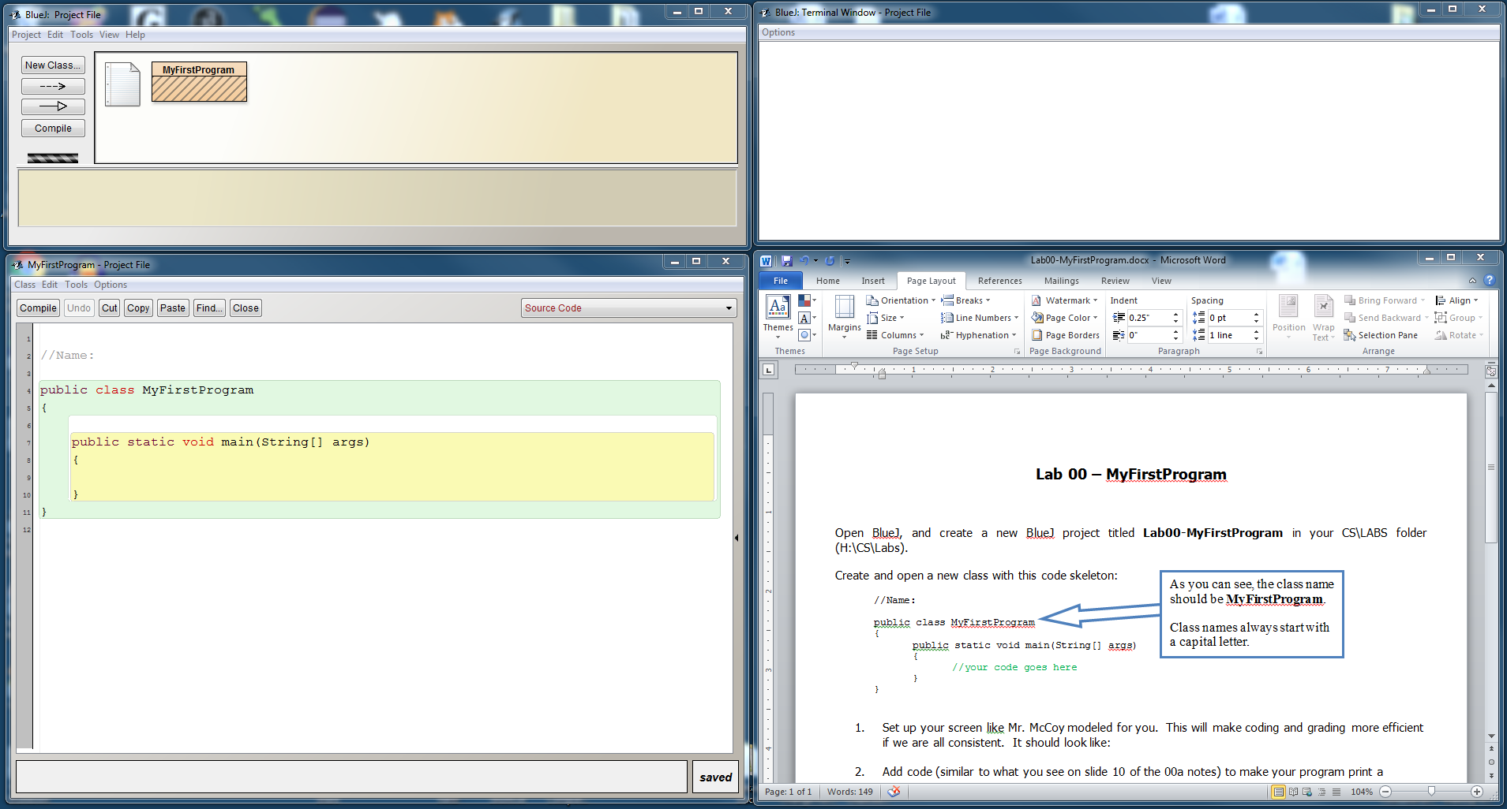
2. Add a line of code containing a print statement to make your program print a message. (There’s an example of a print state on slide 10 of the 00a notes.)
3. Compile your program. If you get errors, fix them! (Not sure how to compile? Look at slide 11 of your notes.)
4. Run your program to see if it works. (Not sure how to run? Instructions on slide 12).
5. Slide 15 of the notes shows how you should set up your terminal window. If you don’t set it correctly you will run into problems later on. **Make sure you’ve turned on those 2 options from slide 15!!!**
6. Once you’ve done all the things listed here, show your teacher. (Lab check)